ACTIVITY: Orbiter Labeling

Directions:
Use the keywords below to label the orbiter diagrams found at the bottom of this sheet.

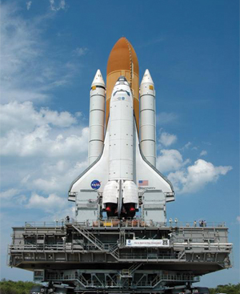
Body Flap: A control surface hinged to the lower section of the aft fuselage. It is used during descent to control the motion of pitch.
Cargo Bay: The center of the orbiter's fuselage also called the payload bay.

Delta Wings: A sweepback wing design that looks like a triangle from above.

Elevon: A control surface used when the returning Shuttle enters the atmosphere; it acts like a combination of an aircraft elevator and aileron, controlling pitch and roll.

Flight Deck: Part of the crew compartment; the commander, pilot, missions specialist, and one payload specialist sit here for launch and landing.

Forward Control Thrusters: Small rocket engines that maneuver the orbiter in space. These are located around the orbiter's nose.

Main Landing Gear: Two main landing gears located under the orbiter's belly, each with two tires.

Main Propulsion Engine: Three SSMEs (Space Shuttle Main Engines) located on the orbiter's aft end. The SSME is one of the most advanced rocket engines ever built.

Nose Landing Gear: Landing gear assembly located under the orbiter's nose with two tires.

Orbital Maneuvering System (OMS): Two OMS engines mounted in external pods on each side of the aft fuselage. These power the orbiter during orbital insertion and de-orbit.

Payload Doors: Two curved cargo-bay doors located on the top part of the fuselage and opened soon after reaching orbit.

Reaction Control System (RCS): A set of engines located on each side of the aft fuselage that are used to control the motions of roll, pitch and yaw when the orbiter is maneuvering out of orbit and reentering the atmosphere.

Split Rudder/Speed Brake: A control surface located on the vertical stabilizer (tail section) that splits apart vertically to increase drag and slow the aircraft during descent and landing. When both sections are moved together, they act as a rudder to control the motion of yaw.
